**AutoMob-Mechanic Web Application**

**Objective of Project:** To develop a responsive web app for an automobile service center that allows users to explore services and book car servicing or repair appointments online.

**Problem Statement(s):**

* No simple platform for booking car services online.
* Manual appointment systems lead to delays and miscommunication.
* Users need a smooth way to view services and schedule maintenance.

**Code Pen Link:**

**Output:**

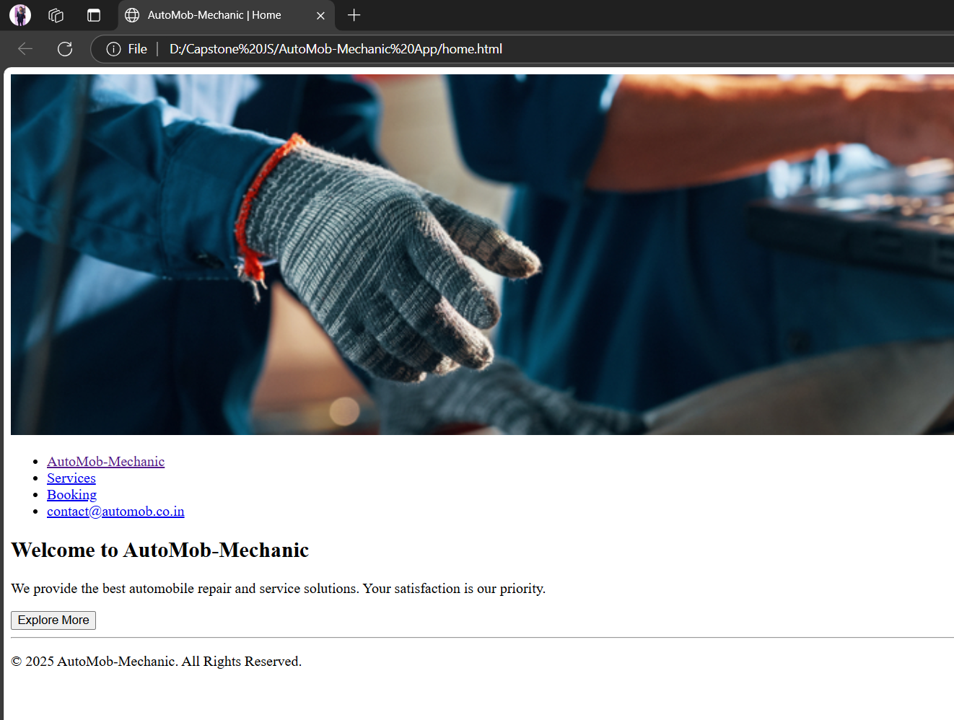

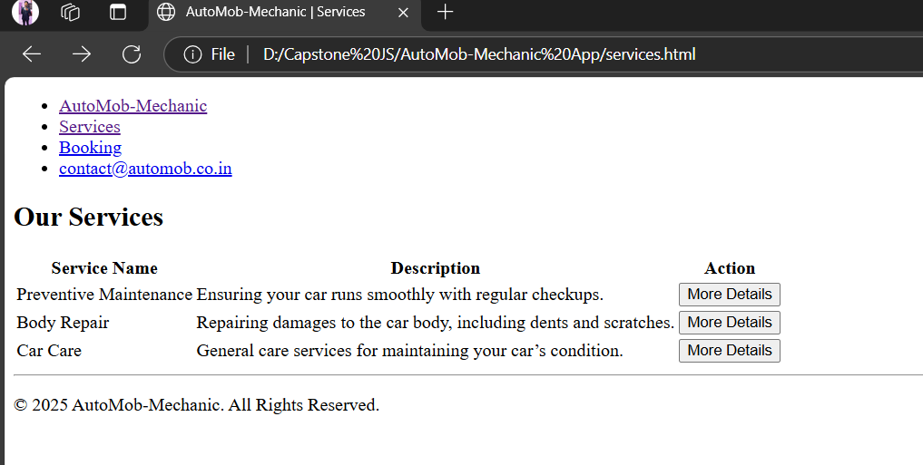

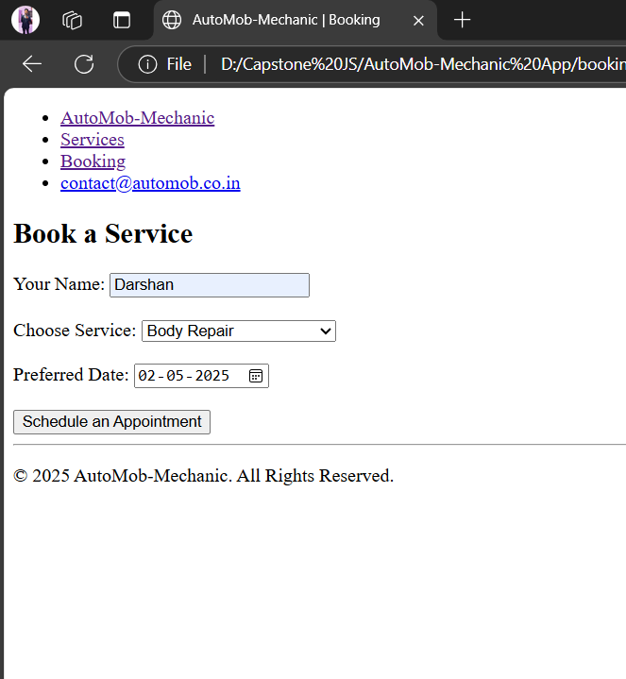

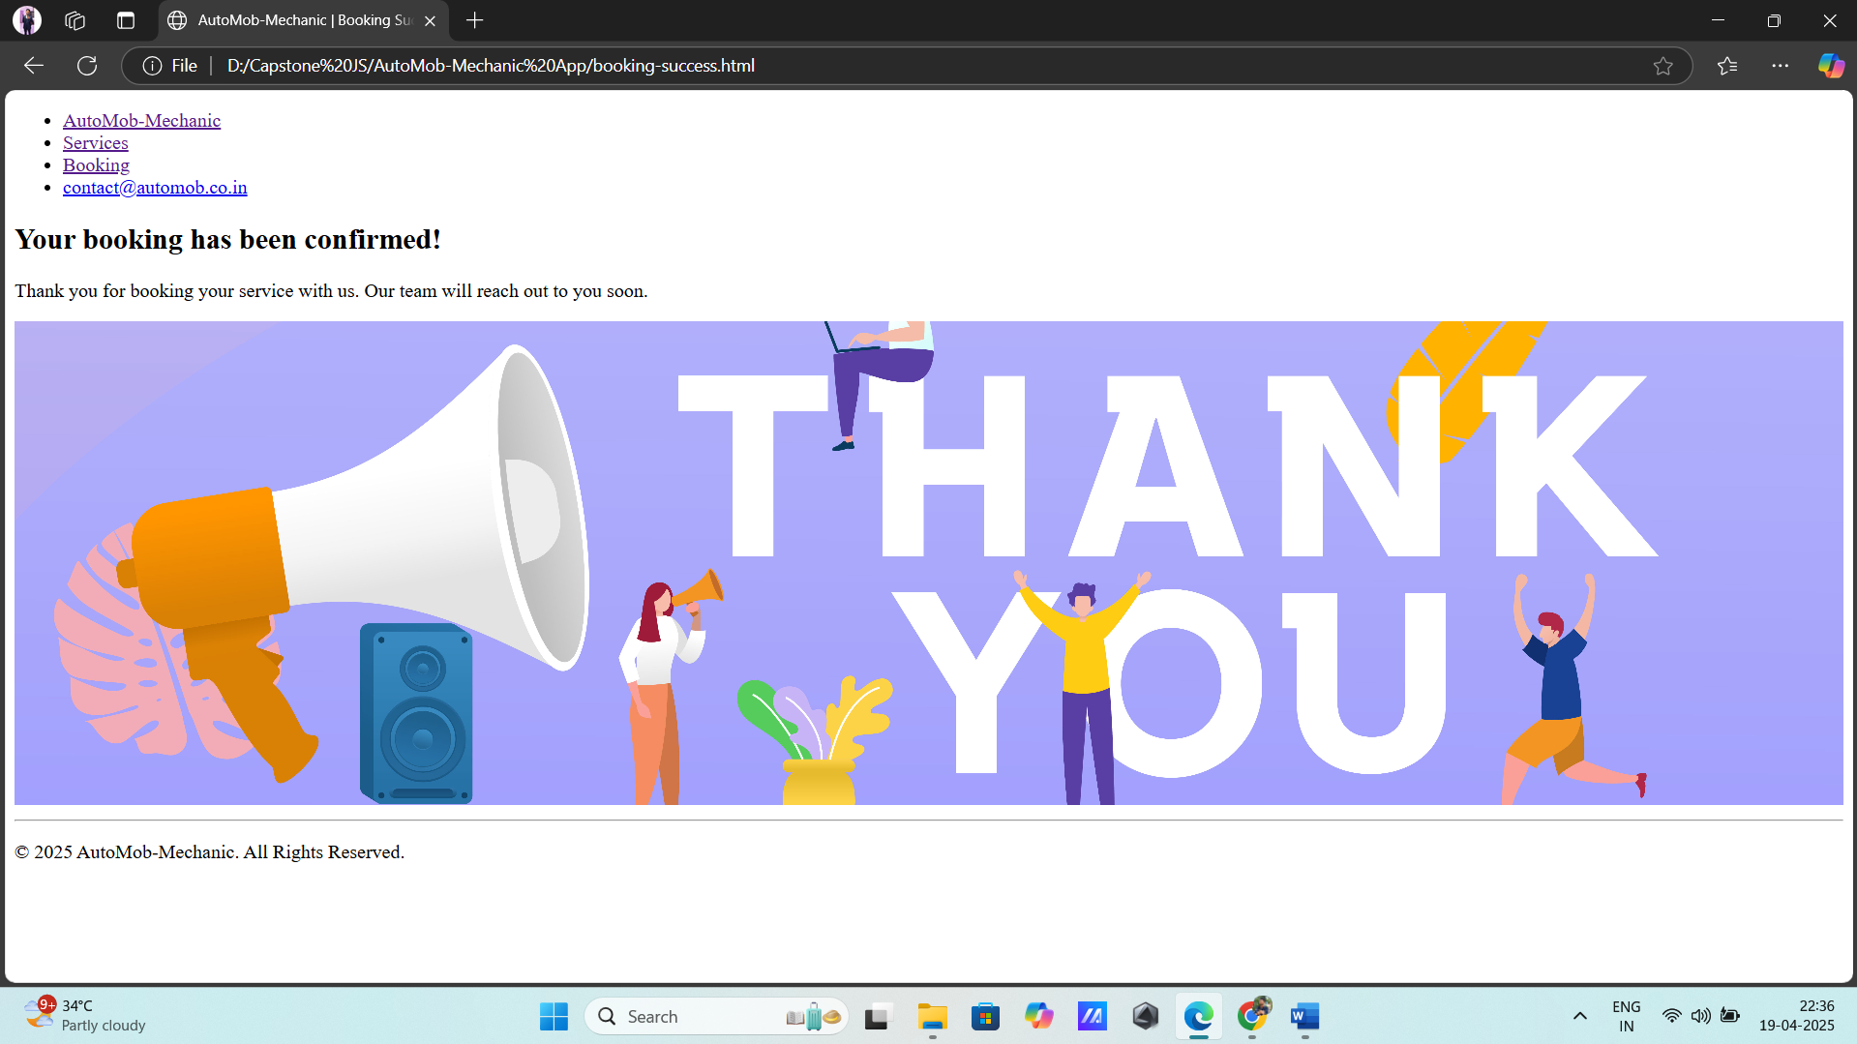

**Conclusion and Outcome:** This project provides a fully functional front-end car service platform. Users can explore services, fill booking forms, and receive confirmations. It improves efficiency and simulates a real-world booking system using only HTML, CSS, and JavaScript.